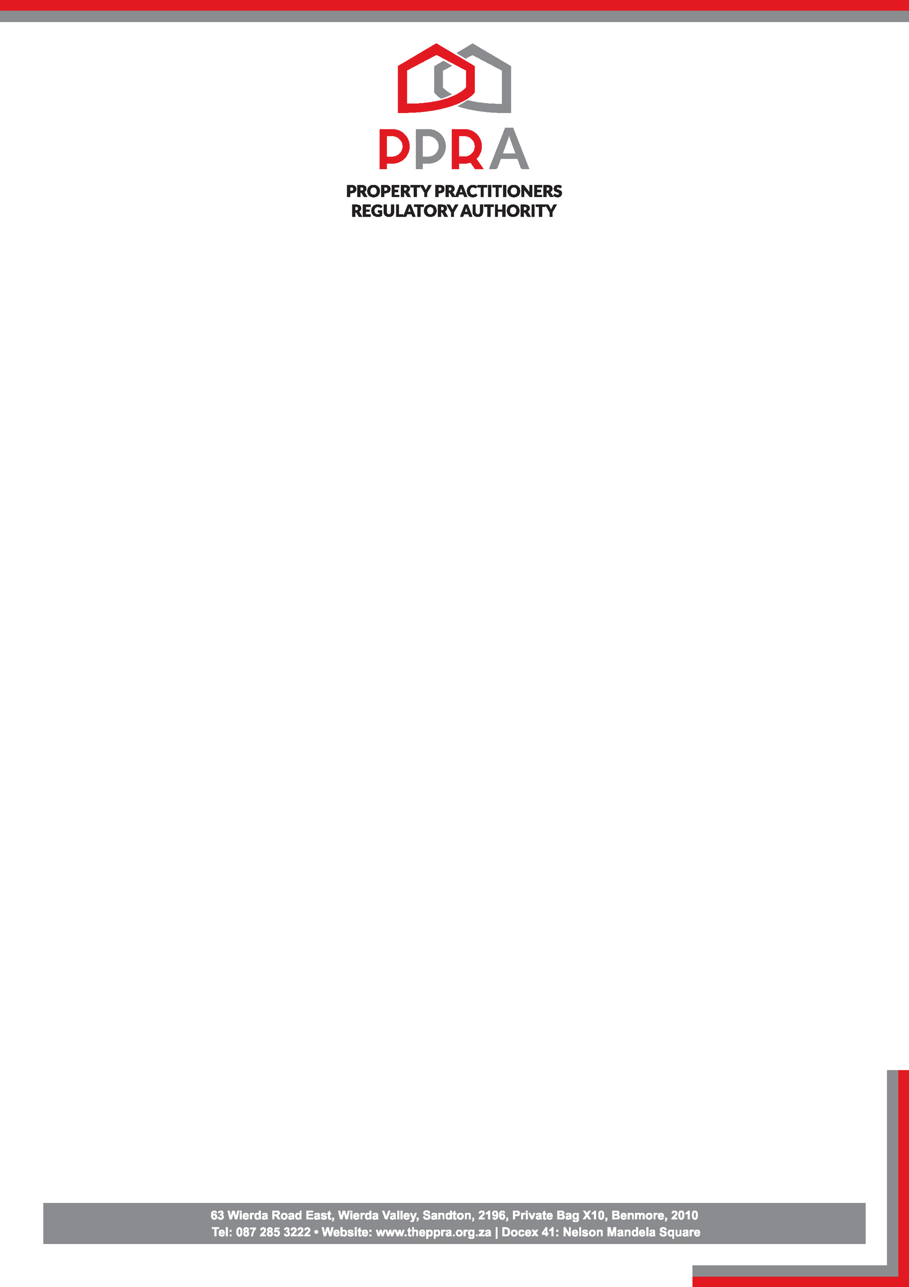
‘.,

NOTICE: CPD CONTACT SESSIONS

The Property Practitioner Regulatory Authority wishes to inform all property practitioners that Continuing Professional Development (CPD) contact sessions have resumed.

We are starting with the following provinces:

- Gauteng – Sandton
- Western Cape – Cape Town
- KwaZulu-Natal – Durban

Full details, including session schedules and booking procedures, are available on the MYCPD Portal. Property practitioners are required to register for the sessions via the portal.
Please be reminded that, to remain compliant, property practitioners must acquire a minimum of 4 CPD points per year.
All practitioners are urged to ensure timely registration and attendance.

The CPD fee for 2026 is R1,837. An early bird fee of R1,775 was available until 31 March 2026.

Issued by:

CPD Department
Date:20 April 2026

